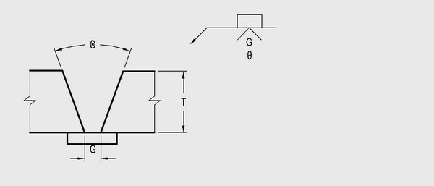

**D1.2 B-L-1**

**60°**

**60°**

**60°**

**G = 1/8 in to ¼ in in**

GTAW