

[Type the document title]

**[Year]**

Tyco User

Tyco

[Pick the date]

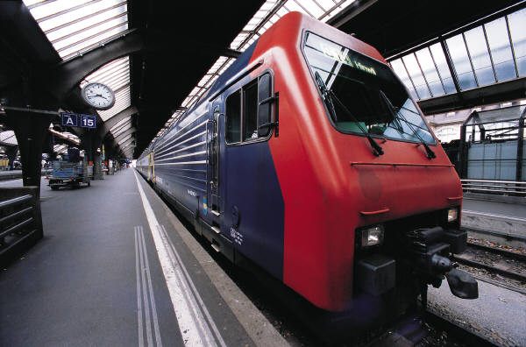

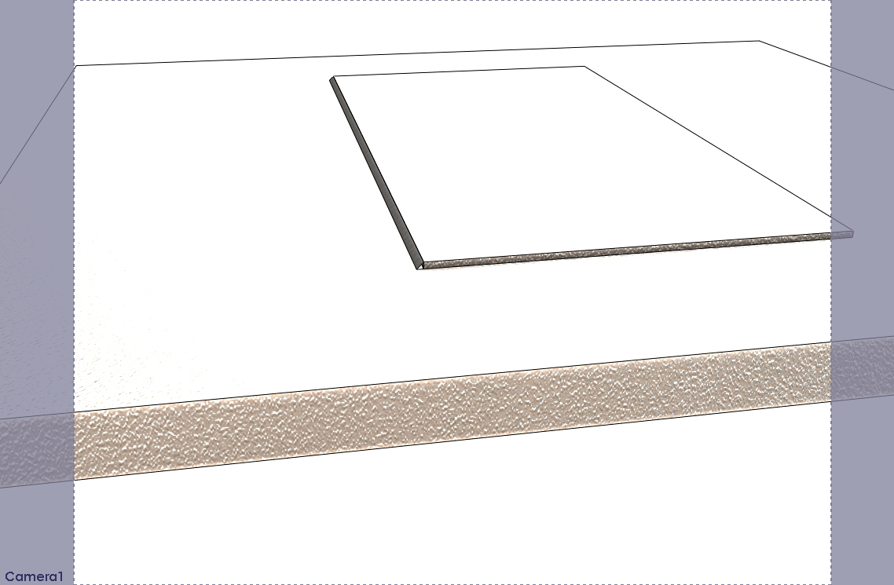

FILLET WELD BEAD

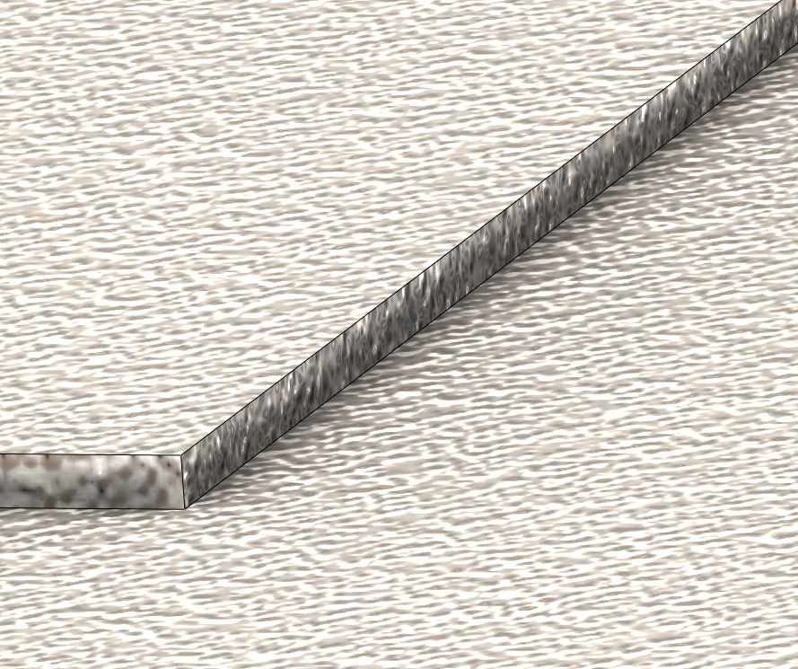

FUSION WELD BEAD IS SEAMLESS

