**WELDER QUALIFICATION PROCEDURE**

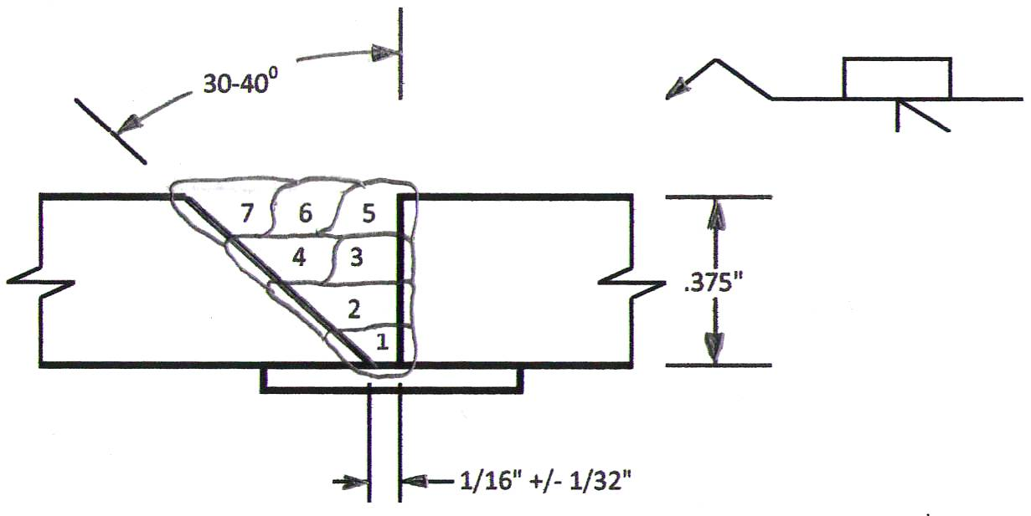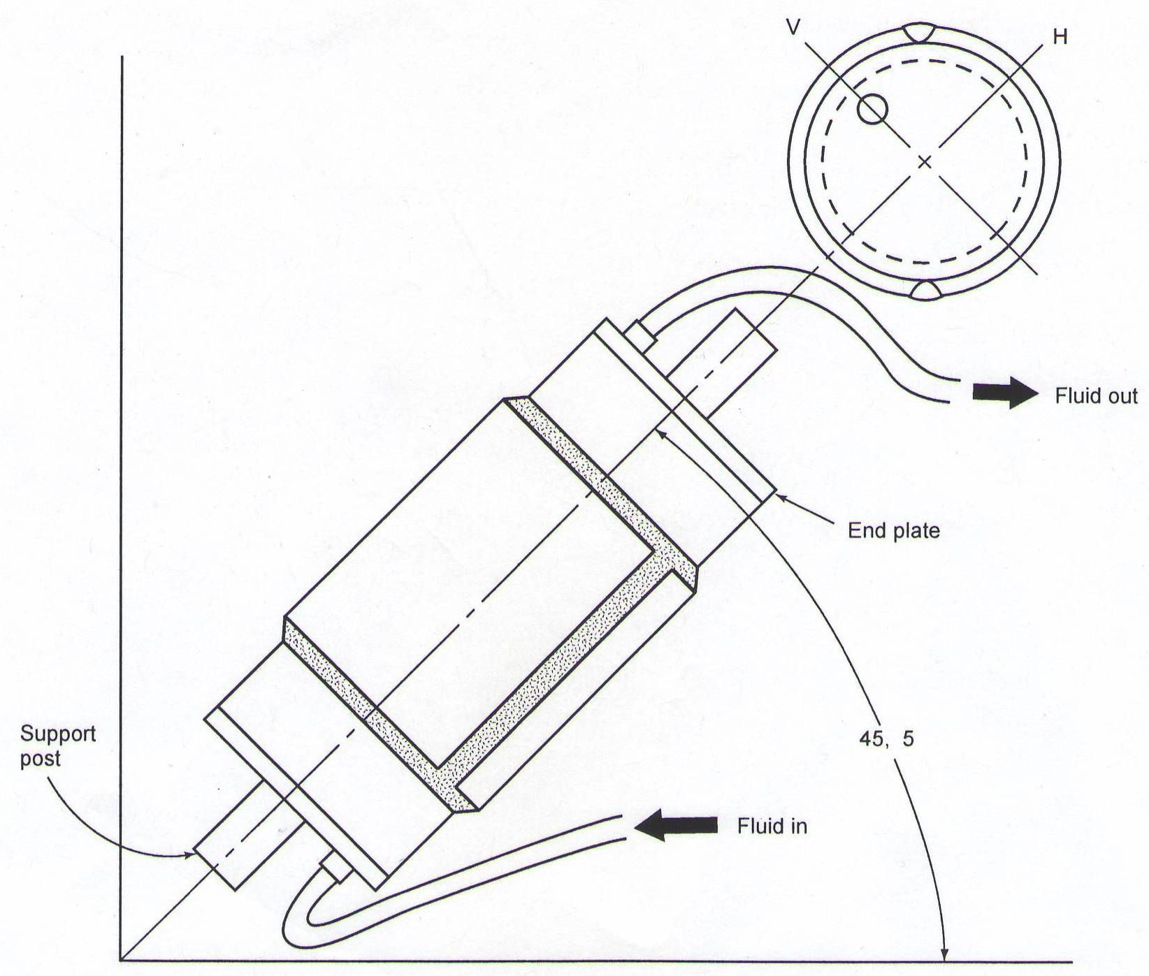

**SEE VIEW B**

**SEE VIEW A**

**VIEW A**

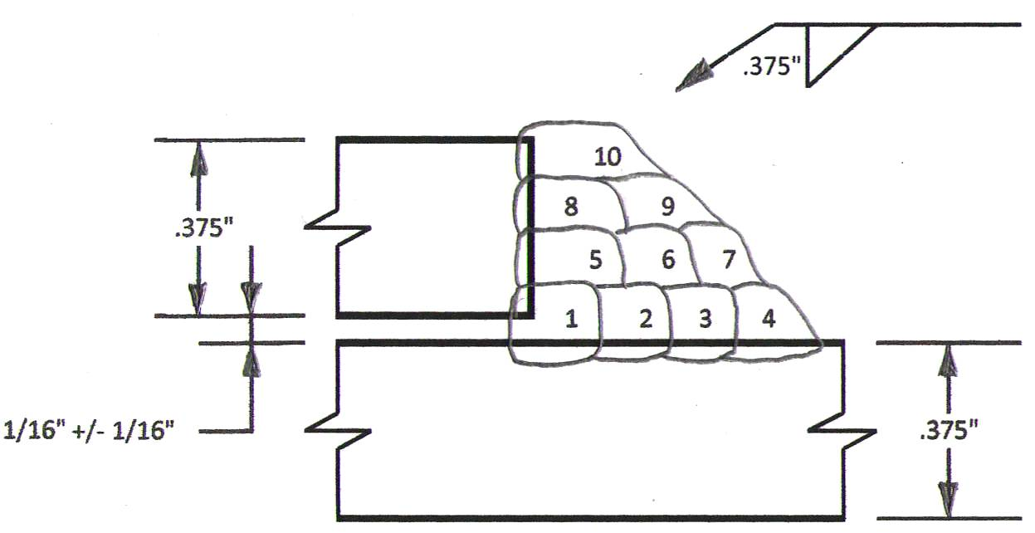

NOTES:

* FILLER METAL ROD SIZE MAY INCREASE OR DECREASE BY ONE ROD

SIZE DIAMETER AT WELDERS DISCRETION.

* AN INCREASE OR DECREASE IN THE NUMBER OF PASSES MAY

BE MADE, AS REQUIRED, DUE TO WALL THICKNESS VARIATION.

* PASSES SHALL BE MADE IN ACCORDANCE WITH THE WELDING

PARAMETERS FOR THE FILLER ROD SIZE BEING USED.

* VOLTAGE MEASURED ACROSS WELDING CABLES DURING

**VIEW B**

PROCEDURE DEVELOPMENT.

* STRIPPERS ARE PERMISSABLE AT WELDER’S DISCRETION.
* EACH PASS MUST BE COMPLETED PRIOR TO START OF NEXT PASS.